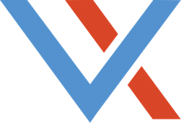

Ideal Customer Profile
Who do you want to do business with?

The purpose of this exercise is not determine all the different types of customers you may have currently, but rather identifying key attributes of the type of customer that is be best suited for your business — whether you currently do business with them or not.

Business Demographics
- What do they do?
- What are they called?
- What’s their annual revenue?
- Where are they located?

Company Characteristics
- What do they value?
- What do they care about?
- What is the culture?
- Other attributes?

Customer Relationship
- What is our ideal relationship with our customer? Direct/indirect?
- What buying and influencing roles should an
ideal customer have?
- What are the roles, titles and layers that impact the relationship?

Industries
- What industries do we want to sell to?
- Who does our ideal customer sell to?
- What is the culture?

Product Characteristics
- What products to they create?
- What types of attributes does their product have?
- Size? Type? Materials? Volume? Quality?

Examples
- What ideal customers do we already have?
- List a few aspirational ideal customers.

thevxgroup.com

